

Centre for Pre-University Studies
Foundation of Computing
Semester 2
Academic Year 2020/2021

FPIT1064 WEB DEVELOPMENT
ASSIGNMENT REPORT

(To be filled by students)
Assignment Title | :
Tutorial Group | : | FCP1201
Team member | : | STUDENT NAME | STUDENT ID | FINAL MARK (100%)  (To be filled by supervisor)
Team member | : | Cheok Jia Wei | 2011WPF491
Team member | : | Huan Jen Ning | 2011WPF412
Team member | : | Sam Yew Theng
Supervisor | :
(To be filled by supervisor)
Date/Time Received | : | [ ] On time / [ ] Late
Remarks  (If any) | :
Signature | :

Tunku Abdul Rahman University College Plagiarism Policy

All students’ works submitted for assessment must be attached with the Coursework Declaration form as shown below:

Semester/Year: Sem 2, Year 1
Course Code & Title(s): FPIT1064 Web Development

Declaration
We have confirmed that we have read all the terms and conditions of the plagiarism policy of Tunku Abdul Rahman University College and will comply with them.

We declare that this assignment(s) is free of all forms of plagiarism and is our own properly derived work for all intents and purposes.

We also confirm that the same work has been verified by anti-plagiarism software, where appropriate.

For group:
Name (Group) | Signature | Date
Cheok Jia Wei
Huan Jen Ning
Sam Yew Theng

CPUS-TAR-UC_Plagiarism_Policy_2014

Marking Sheet |  | GROUP MARK
(A) WEB DEVELOPMENT – 50 mark
Conceptualization and Analysis (3) | 1. Full description of the site’s long-term and short-term goals or mission.  2. Able to identify the intended target audience, their purpose and goals.  3. Able to state what the website will do and the information on the website that needs to be presented.
Page Layout (11) | 1. Appealing to target audience  2. Consistent site header/logo  3. Consistent navigation area  4. Informative page title  5. Appropriate information in the page footer area:  - last update  - contact email address  6. Good use of basic design principles  - repetition  - contrast  - proximity  - alignment  7. Balance of text/graphics/white space on page
Navigation (6) | 1. Label navigation links clearly and consistently  2. Use clear text links in the footer section of the page  3. Structure navigation as an unordered list  4. Appropriate text for hyperlinks  5. Indicate visited/non-visited status  6. All hyperlinks work
Fonts (4) | 1. Use common fonts (such as Arial, Verdana, Georgia, or Times New Roman)  2. Consistent use of fonts, font sizes, and font colors
Color and Graphics (7) | 1. Consistent use of color  2. Sufficient contrast for background and text color  3. Use color to convey meaning  4. Use color to enhance the site  5. Use graphics to enhance the site  6. Each graphic used, serve a clear purpose  7. Provide alternate text equivalent to graphics
Video and audio (5) | 1. Use audio file with clear purpose  2. Use audio file to enhance the site  3. Use video file with clear purpose  4. Use video file to enhance the site  5. Provide text descriptions or captions to video and audio files
Content Presentation (7) | 1. Use appropriate writing techniques (Avoid long blocks of text, Use bullet points, Use headings and subheadings, Use short paragraphs)  2. Provide meaningful and useful information  3. Organize content in a consistent manner  4. Information is easy to find (minimal clicks)
Programming (4) | 1. HTML and CSS code written by the candidate is included.  2. Good technical competence in programming shown by a self-documented program listing that makes good use of meaningful identifier names, indentation and formatting.  3. The code should be annotated with comments so that the presentation of the solution can be easily followed.  4. The code should be validated by using the HTML or CSS code validator.
Final Report (3) | 1. All essential details are given.  2. Good elaborations.  3. The report is complete, well organised with good use of illustrations.

Marking Sheet |  |  |  |  | INDIVIDUAL MARK
(B) TEAMWORK – 10 mark |  |  |  |  | Student(1) | Student(2) | Student(3)
Contribution and involvement  (Self-Appraisal Report) (3) | 1  Little involvement and little contribution to the assignment.  No or little technical discussions. Most of the contents are irrelevant. | 2  Average involvement and contribution to the assignment.  Able to demonstrate fair understanding on the technical details. | 3  High involvement and contribution to the assignment.  Able to demonstrate good understanding on the technical details.
Team Work  (Tutor and peer assessment) (3) | 1  Not effective and committed to the team. | 2  Able to work effectively with all team members. | 3  Highly effective and committed team player.
Presentation (4) | 1  Didn’t present for the presentation. | 2  Poor presentation skill. Able to answer some of the questions, with minimal technical details. | 3  Average presentation skill. Able to answer most of the questions, with good amount of technical details. | 4  Good presentation skill. Able to answer all questions, with good amount of technical details.
TOTAL
(GROUP MARK + INDIVIDUAL MARK)
60 mark

Table of Contents

 | Page
Declaration form | 2
Mark Sheet | 3-5
Table of Contents | 6
Conceptualization and Analysis
Design
Production
Self-Appraisal Report

Conceptualization and Analysis
Objectives
Our website aims to promote Instagram to more people and also allow people to know more about Instagram.

Target Audience
All age and all genders.

Requirements
Have to be above age 16.

Design
Site map
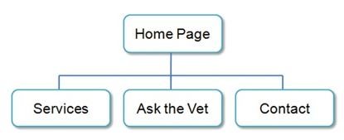
Page layout
(1) Homepage

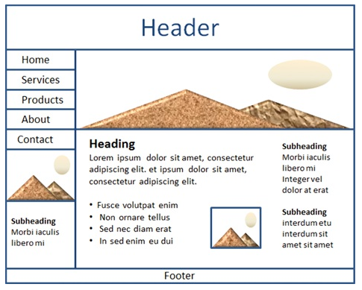

Production
Sample print out screens

(1) Homepage

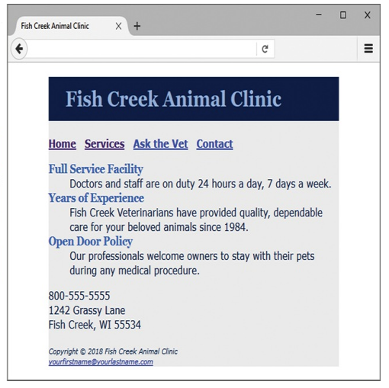

Self-Appraisal Report
Name:  Cheok Jia Wei | Tutorial Group:  FCP1201 | Group leader:  Cheok Jia Wei
Tasks completion:
Which web page were you in charge? Describe the problems faced when you design the web page.

I was in charge in the home page and the post page. The problem that I face when I design the web page is that we could not find the suitable background picture for our web page.

How much do you think you have achieved your initial aim? How much do you think you have completed the website?

I would say that I had achieved 70-80% of my initial aim. The website is completed but I think it could be better

What are the problems you faced to complete the website? How did (will) you solve the problems?

The problem that I faced to complete the website is it is very hard for us to work together because we are from different parts of the country. We couldn’t discuss our assignment face to face and tracking the work progress is hard. Thus, the communication problem is solved by using the Discord app , Discord allows us to communicate and share our thoughts without any problems and the work progress problem is solved by using the Github app. Github allows us to save our work in one repository thus increasing our efficiency on completing our work.

Initiative:
What are the knowledge / skills that you have learned for doing this assignment?

I’ve learned a lot about the web designing process and also the HTML/CSS language. Furthermore, I’ve also learned how to communicate we others better.

What are the activities that you carried out, that made you gain the new knowledge / skills?

I’ve added background pictures, video and images into my webpage. It made me more familiar to HTML/CSS

What are the activities you did in order to help your member(s) to complete his/her task?

The activities I did in order to help my members is helping them adjust their webpages to make it look better.

Self-reflection:
Please tick on the if it is relevant to you to complete this task:

Peer assessment:
How would you rate the members in your team of the overall contribution to the final work?
Name | Contribution
1)Cheok Jia Wei | S/he has put a lot of effort to improve the work
2)Huan Jen Ning | S/he has put a lot of effort to improve the work
3)Sam Yew Theng | S/he has put a lot of effort to improve the work

Self-Appraisal Report

